**Gesture Based Toddler’s Lock**

**Project Description:**

On many situations parents use their android device as a source of distraction for keeping their kids distracted or silent. Parents have to make sure the data is intact; wallets remain protected or undergo the pain of setting up the device from scratch.

Here’s is a very good suggestion to childproof your android device …

Our project is an attempt to create one such toddler android application that implements a kid lock to the device which enables activity to entertain till its unlocked using gesture technology.

**Create a Parent gesture profile:**

The application allows the parents to create a gesture profile. The parents can either use a symbol, signature or any gesture as their key to unlock the android device.

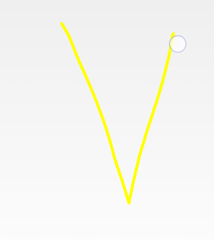

**Lock Your Screen:**

This application launches itself as the lock screen. Once launched it locks all the other applications running and keeps it secured from the kids.

**Device transforms to a colourful toy:**

A kid interactive screen appears which draws full attention of the kid. The screen is fed with colourful videos to entertain the kids for a long period.

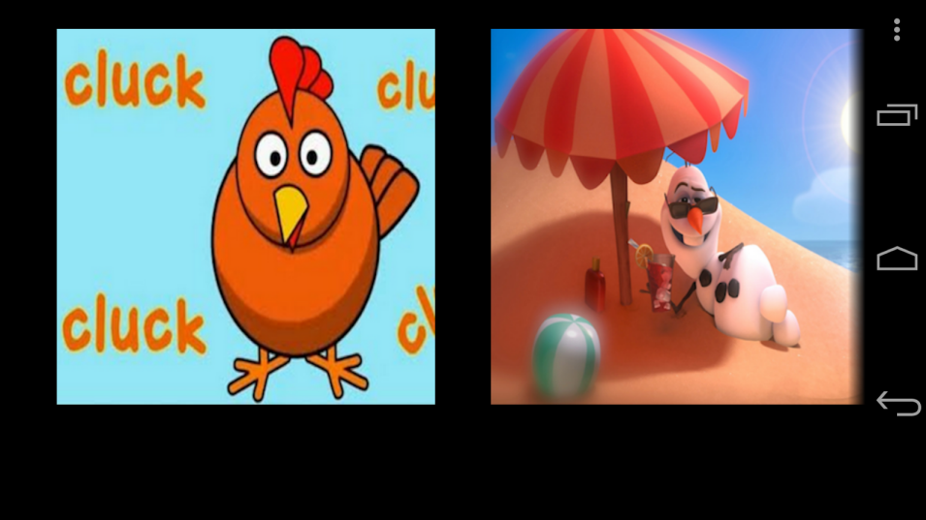

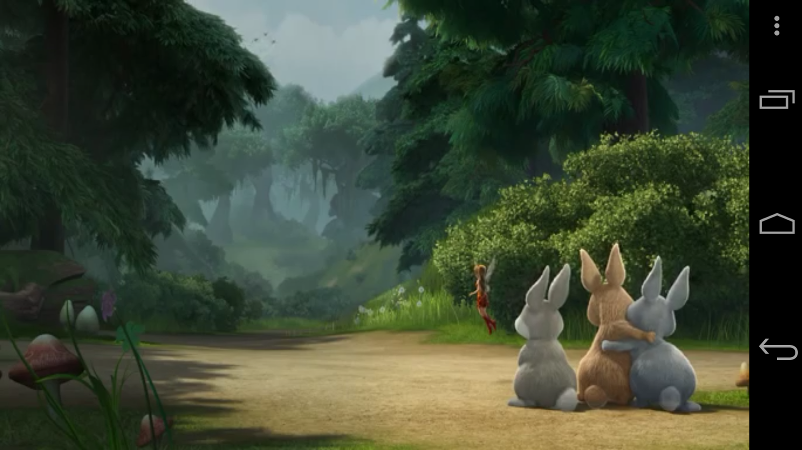

**Unlock by a gesture:**

The gesture fed by the parents as their profile can now be used by them to unlock the device to access the desired application.

